bibliographic Information ツ

Author(s):
Vagner Dos Santos Da Silva; Marcella Giovanna S. Dos Santos; Miguel Felipe Nery Vieira; Victor Santos Matos; Ícaro Nascimento Queiroz; Rebeca Tourinho Lima
Title of article or book (if a chapter in a book, put the chapter # and title here, and put the title of the book in “Title of publication”):
IEEE
Title of publication, including Vol., Num., date (if article in magazine, newspaper, or journal):

Autonomous navigation strategy in quadruped robots for uneven terrain using 2D laser sensor

Page numbers (if article in magazine, newspaper, or journal):
290-295
Publisher:
IEEE
Date published:
05 December 2023
URL (if applicable):
https://ieeexplore.ieee.org/abstract/document/10334730
MLA citation:
V. D. S. Da Silva, M. G. S. D. Santos, M. F. N. Vieira, V. S. Matos, Í. N. Queiroz and R. T. Lima, "Autonomous navigation strategy in quadruped robots for uneven terrain using 2D laser sensor," 2023 Latin American Robotics Symposium (LARS), 2023 Brazilian Symposium on Robotics (SBR), and 2023 Workshop on Robotics in Education (WRE), Salvador, Brazil, 2023, pp. 290-295, doi: 10.1109/LARS/SBR/WRE59448.2023.10333035. keywords: {Legged locomotion;Navigation;Robot sensing systems;Robustness;Quadrupedal robots;Task analysis;Collision avoidance;Quadruped robots;autonomous navigation;simulation;path planning},

Direct quotes: Include Page #s (For each quote, provide some context and/or analysis; you may also want to re-state the information in your own words. Quotes from your sources, and your understanding of them, will make up the bulk of your literature review)
- 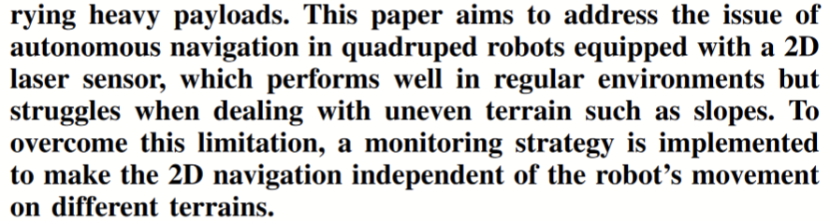p290
- 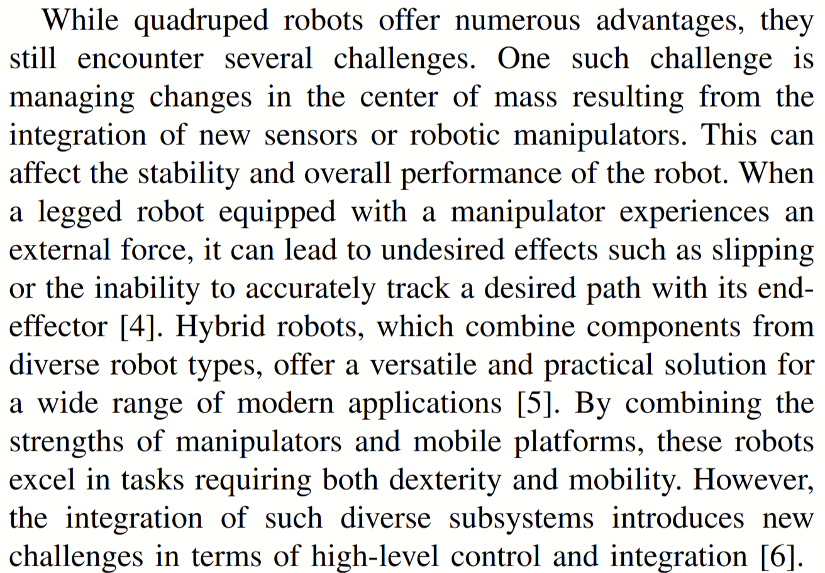p290
- 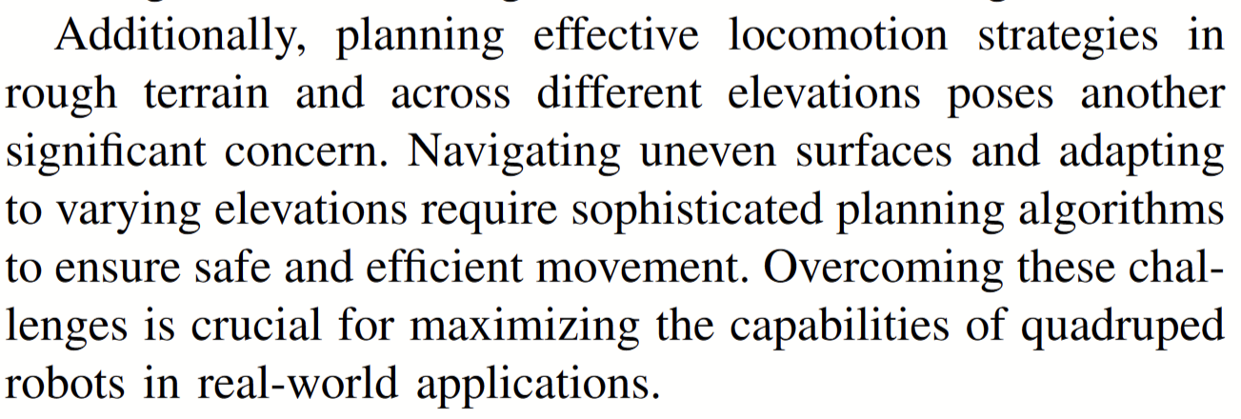p290
- 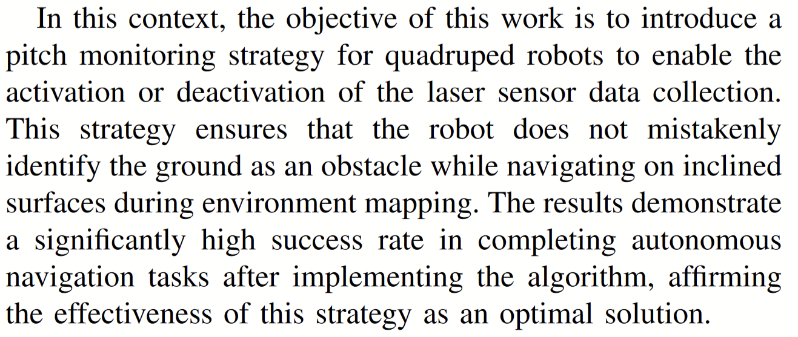p290
- 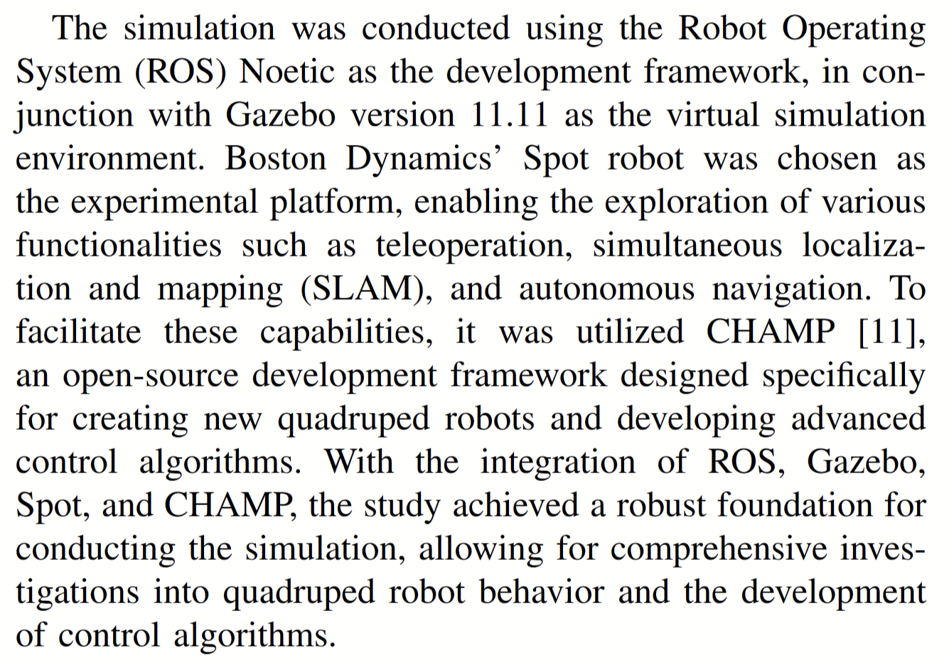p292
- 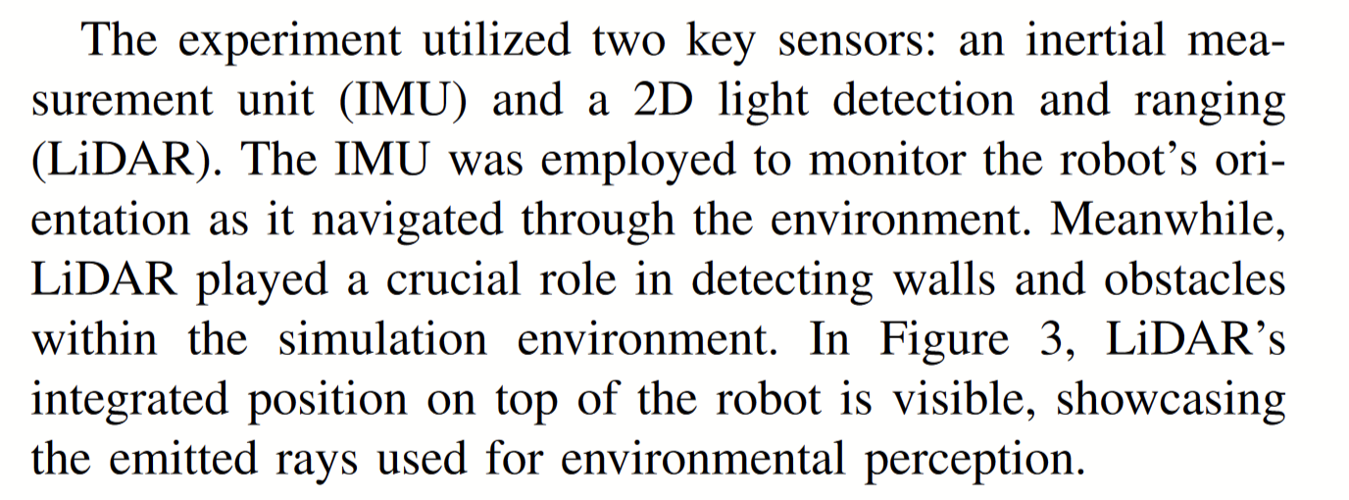p292
- 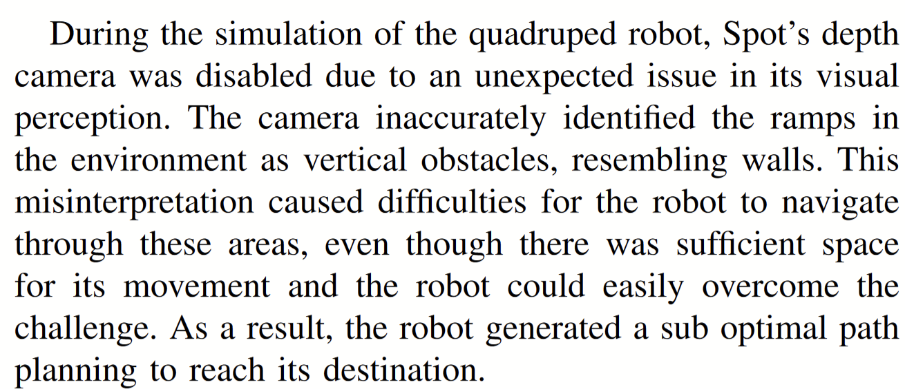p293
- 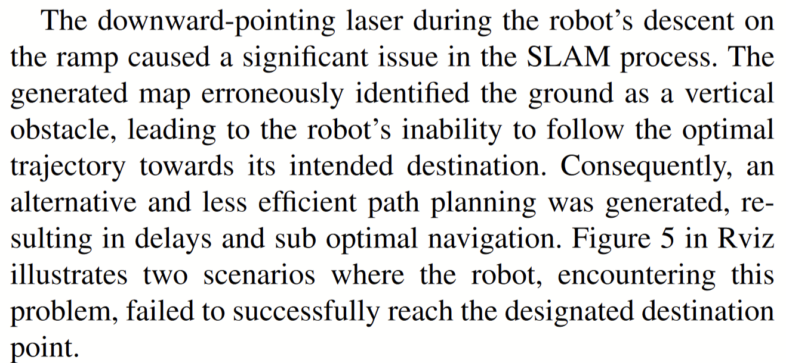p293
- 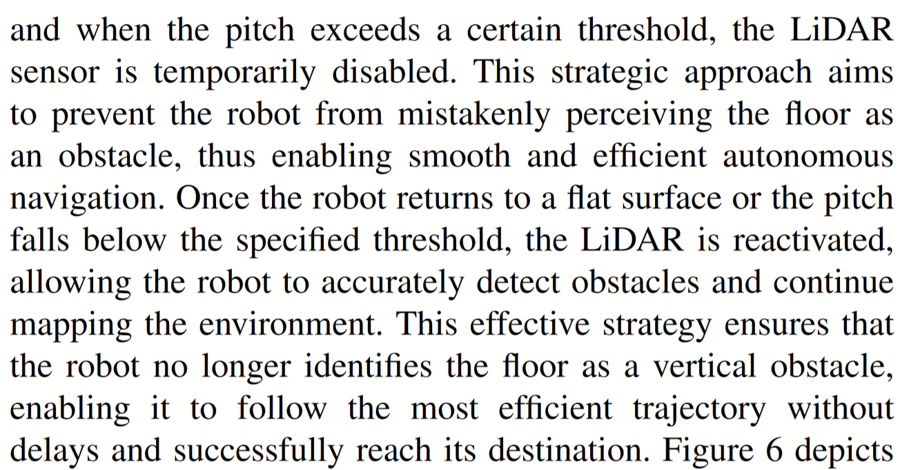p293

Paraphrased Notes: Include Page #s (This is a space for you to track the flow of information, and the ways in which the article engages with other works.)
Q7 is really interesting, talks abt how rgbd cams can detect the floor
Q8 is the same problem but with lidar

Summary of Source (2-4 sentences)
Talks a lot about implementing LiDAR and the struggles along with it. It also briefly touches on RGBD which is super helpful, and compares them.

Does this help me answer my question? Why or why not?
Yes, talks exactly about my topic.

Lingering Questions
It only talks about pitch changes, what about roll and yaw?

Connections to other sources
S

